**ASE LAB ASSIGNMENT 8**

**IMPLEMENTING CRUD API USING MEAN STACK**

**Objective:**

* To understand and run the given source code which implements CRUD operations using MEAN stack.
* Establishing a connection between MongoDB and our application.
* Customizing the UI.

**Prerequisite:**

* WebStorm IDE
* Node
* ExpressJS
* Angular
* MongoDB

**Implementation:**

**MongoDB setup:**

* A MongoDB Atlas account is created in [https://cloud.mongodb.com](https://cloud.mongodb.com/).
* We then select the appropriate cloud provider and region.
* Cluster is created and choose the appropriate connection method.
* Lastly, we create a collection and database for this application.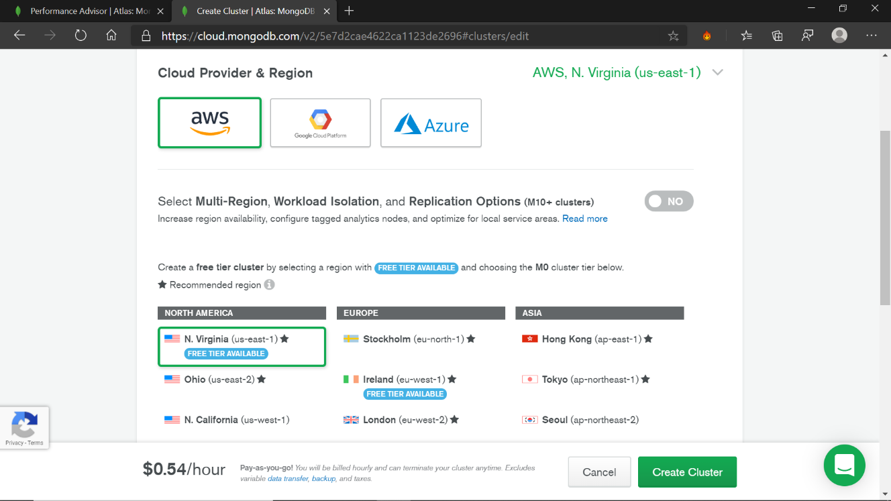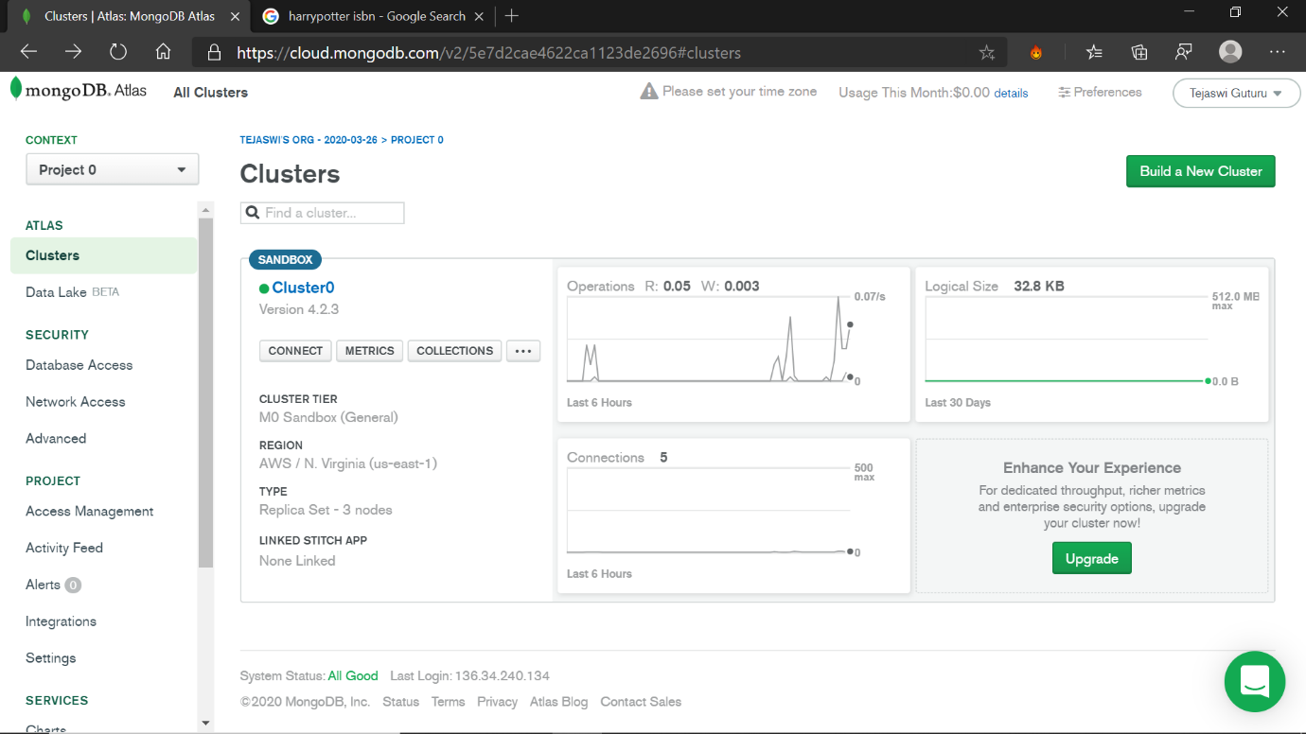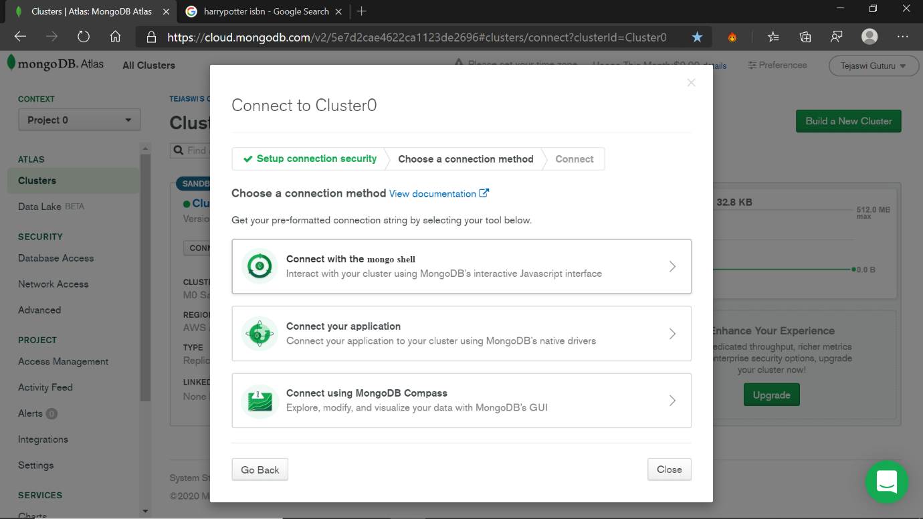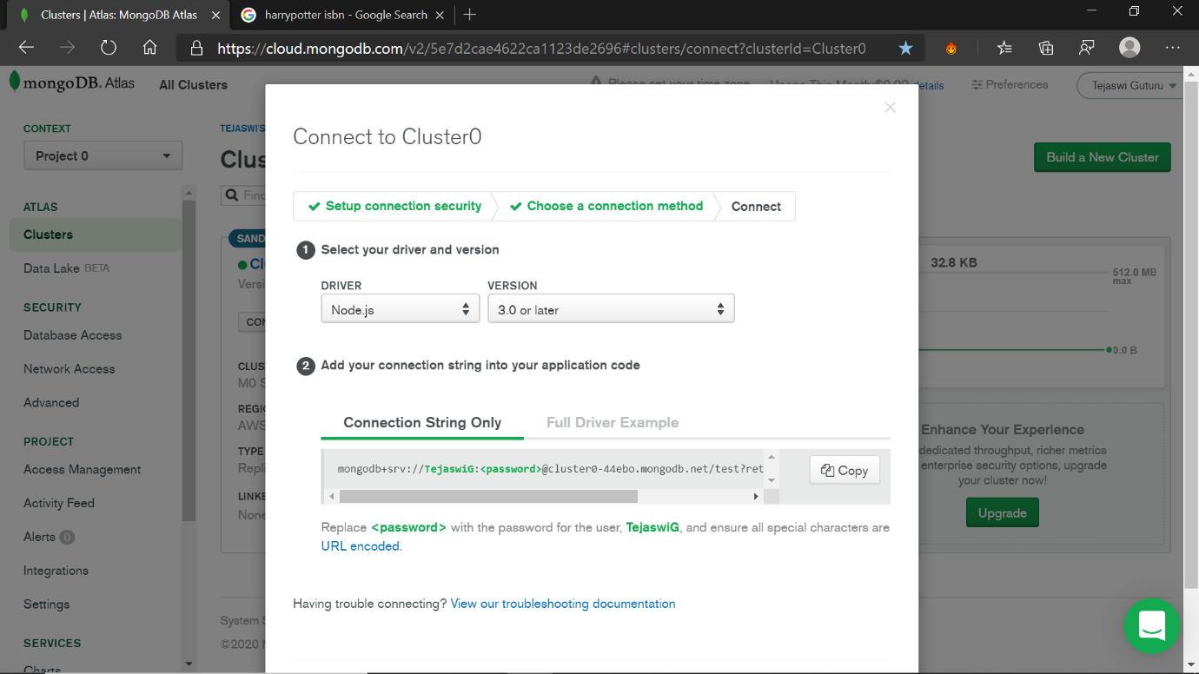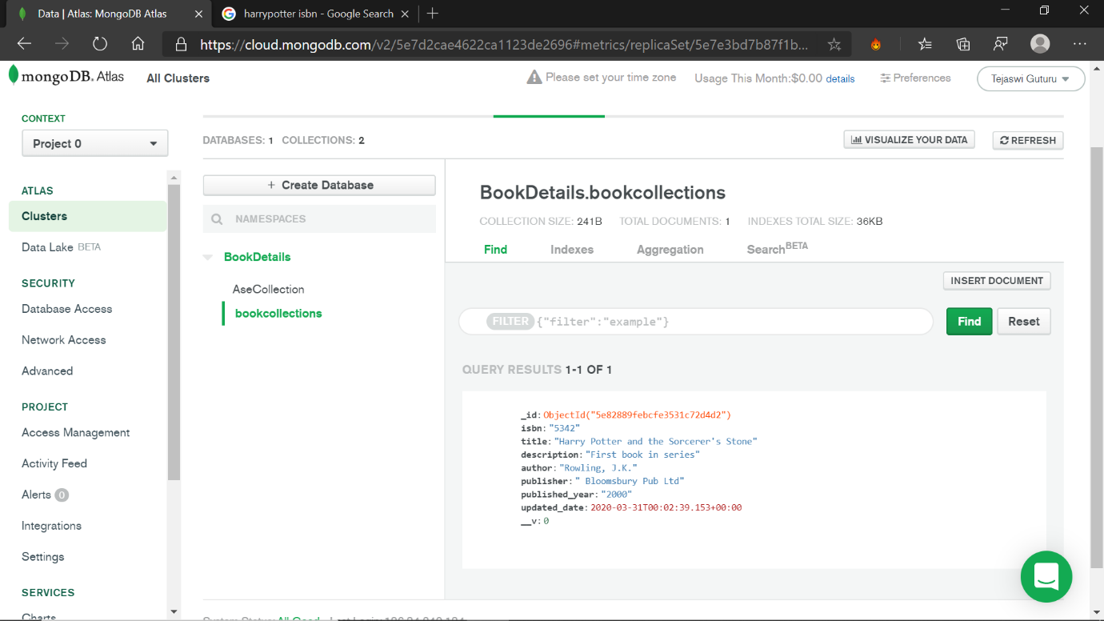

**Connecting MongoDB and Customizing UI:**

The Connection string is embedded in the app.js file in the application.

Routing configuration is modified in the app.module.ts file for the components.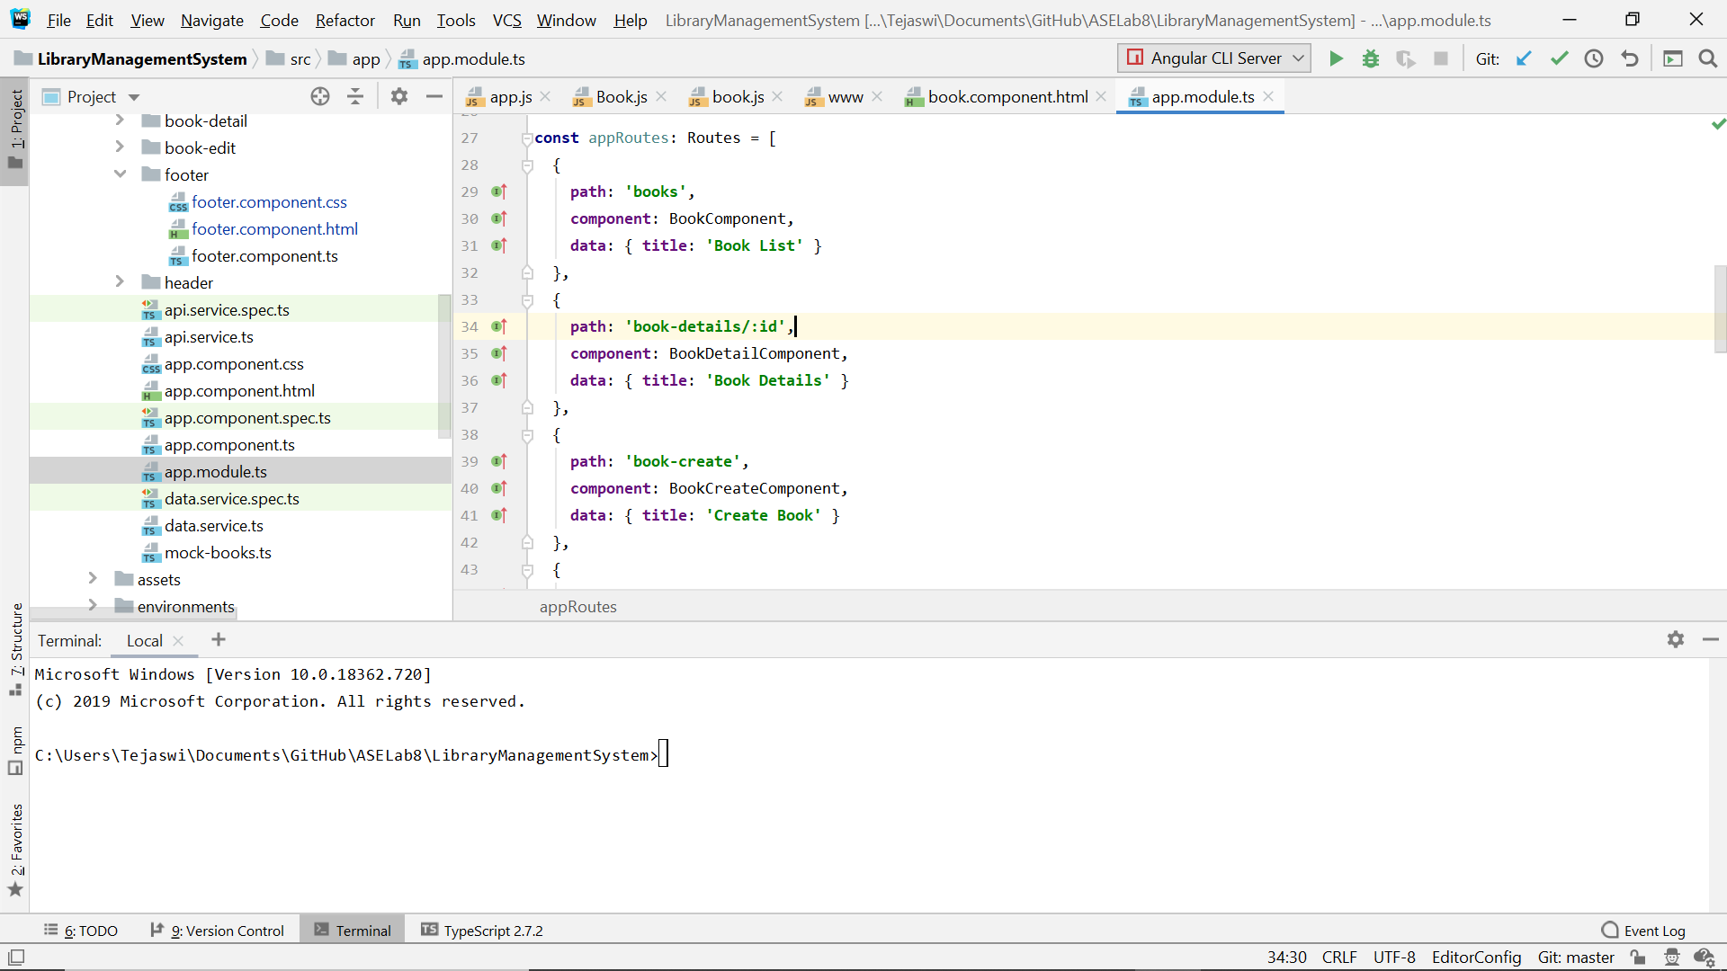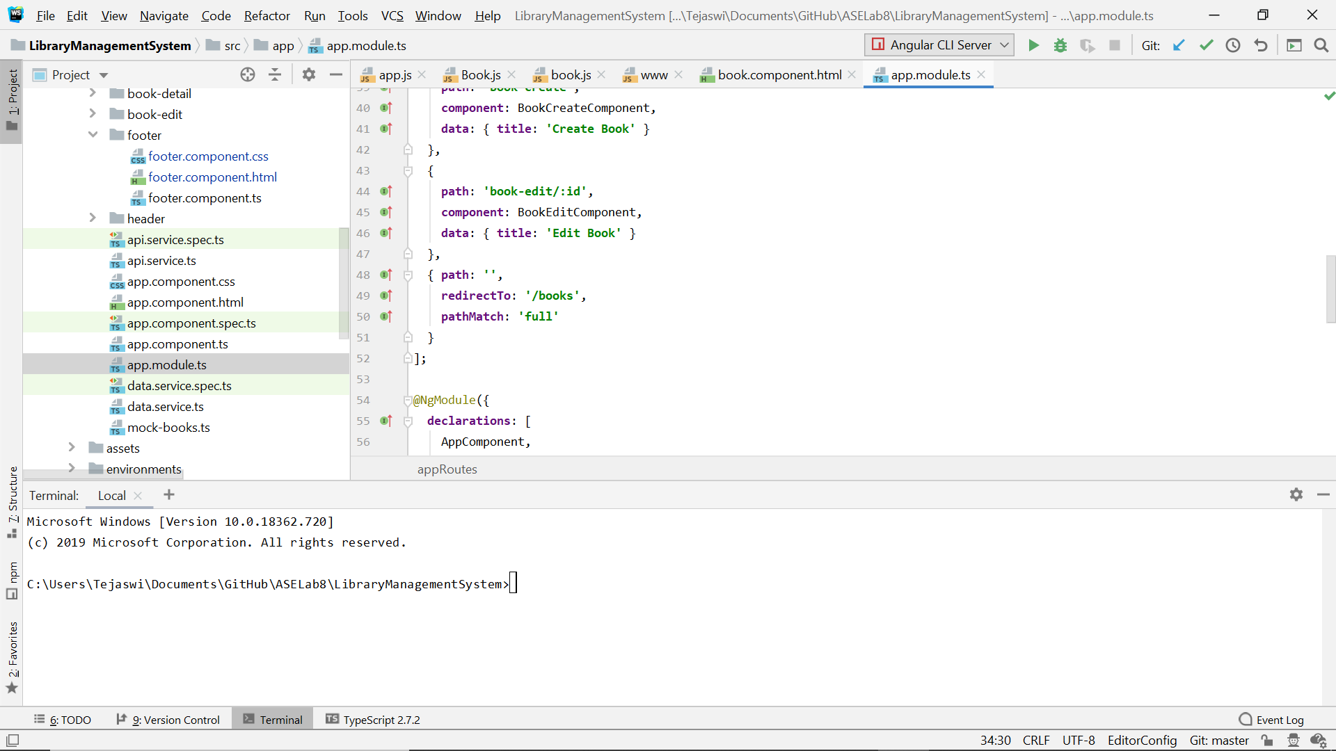

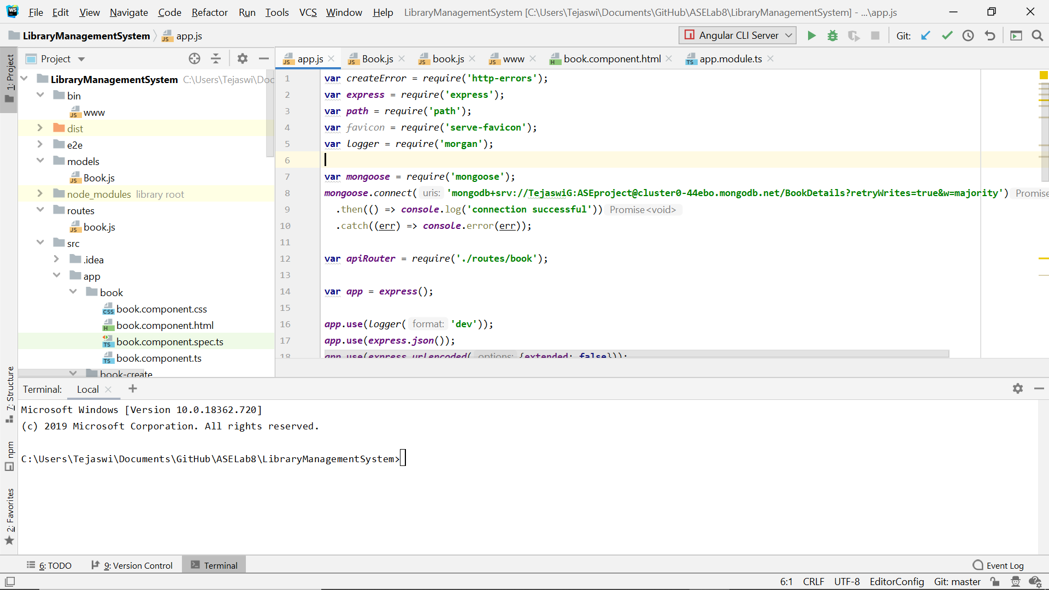

The schema for the document is given in the Book.js file of modules folder. Collection is named book collection.

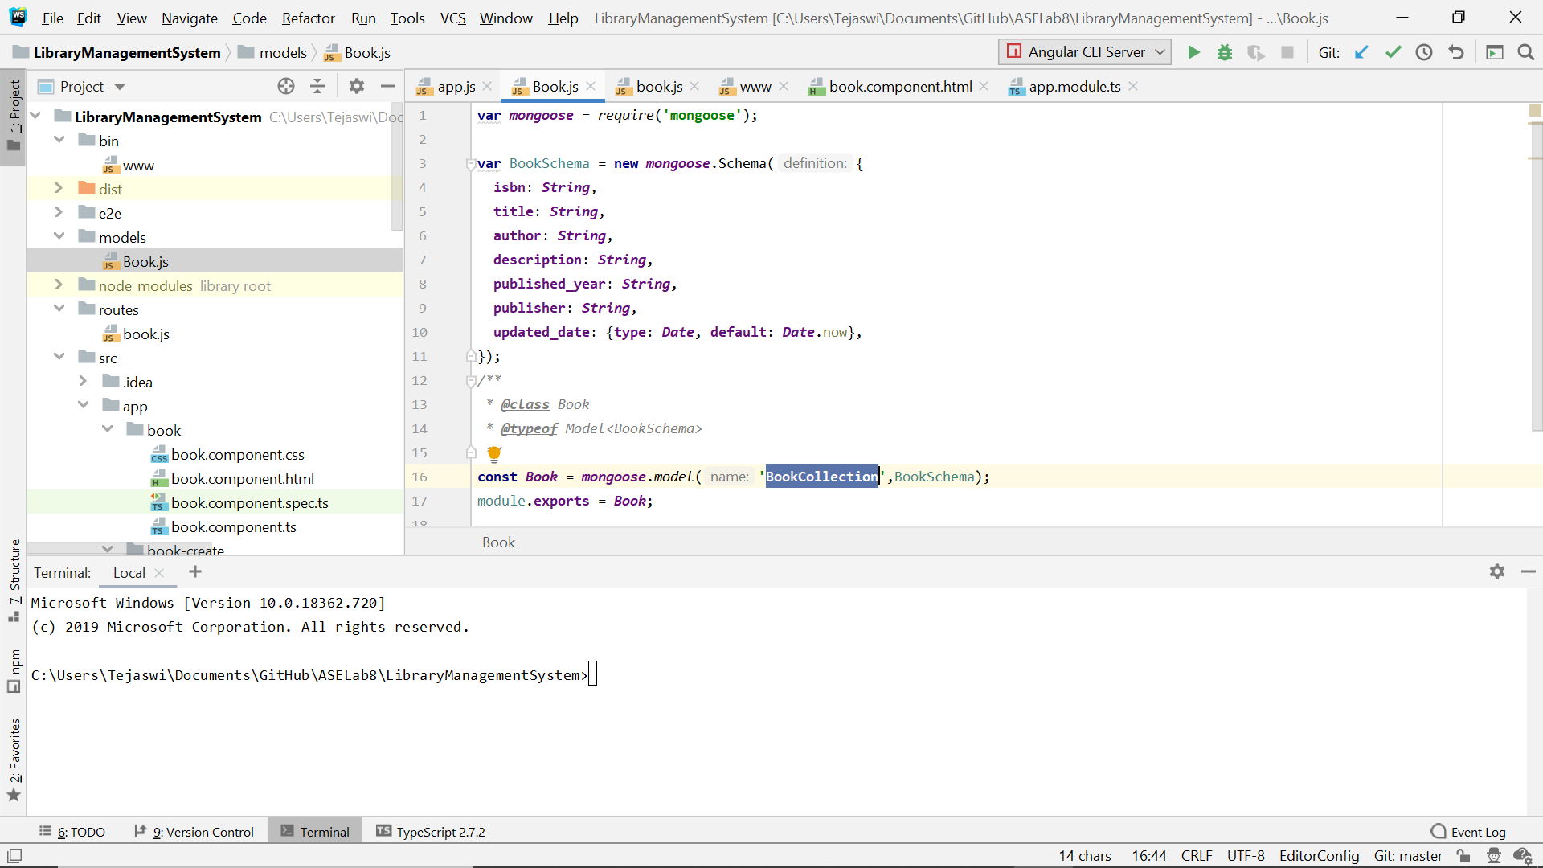

The NodeJS data API operations are defined in the book.js files of routes folder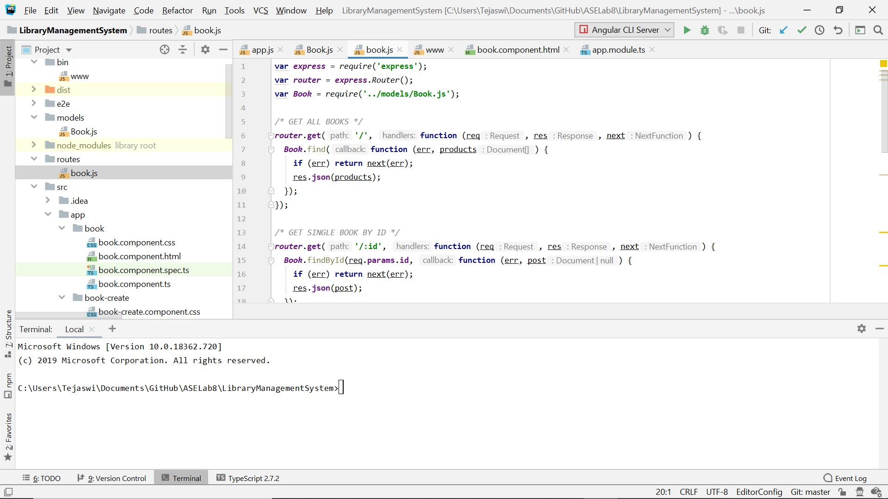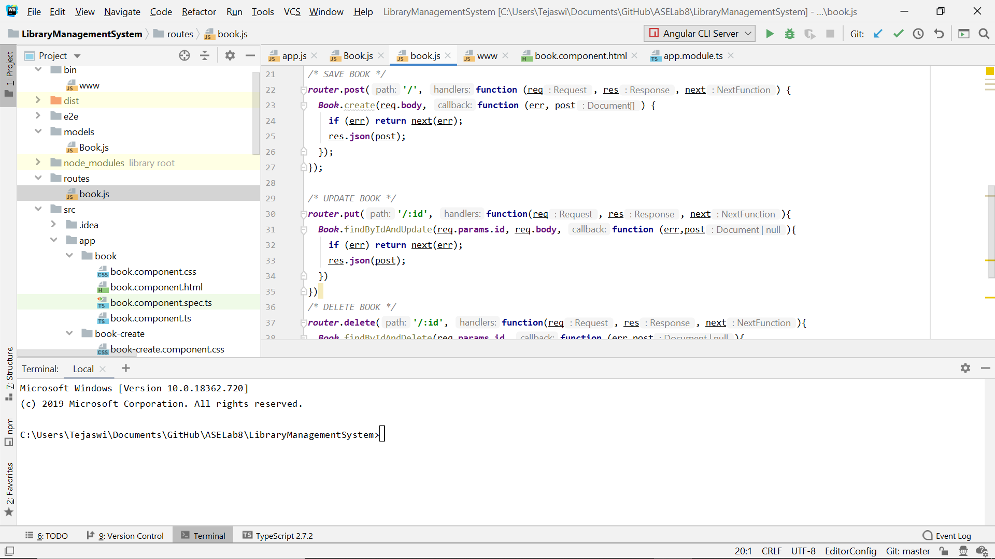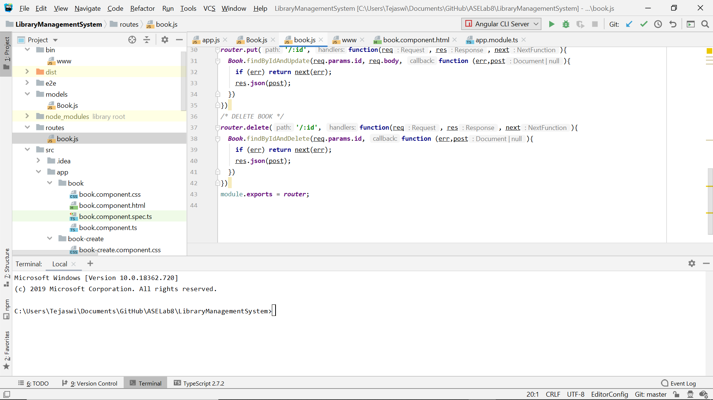

The Bin folder contains the code that listens to the port 3000.

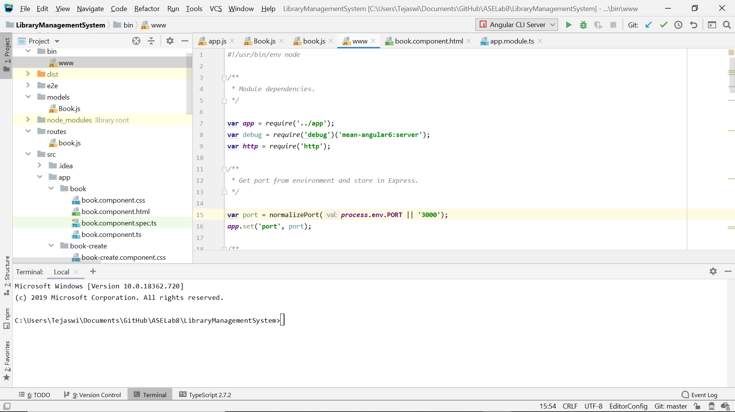

**Output:**

Book list page

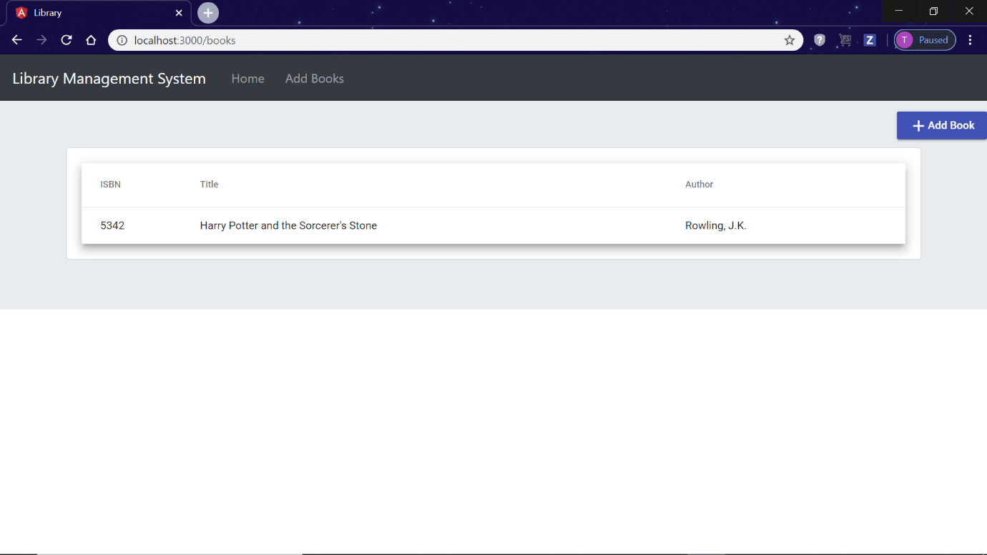

Add Book page

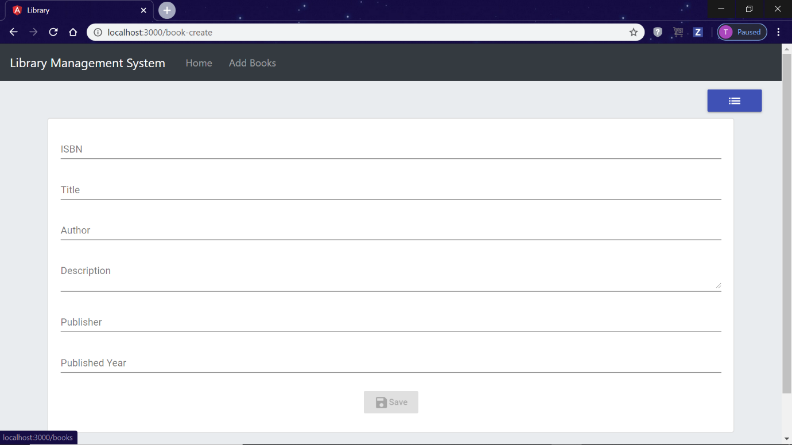

Book details page

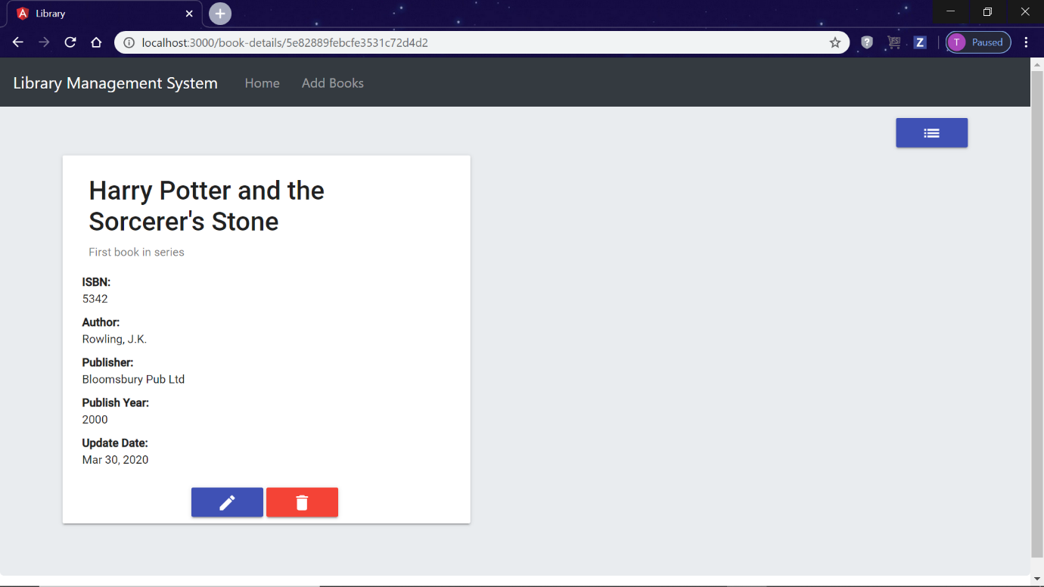

Edit book page

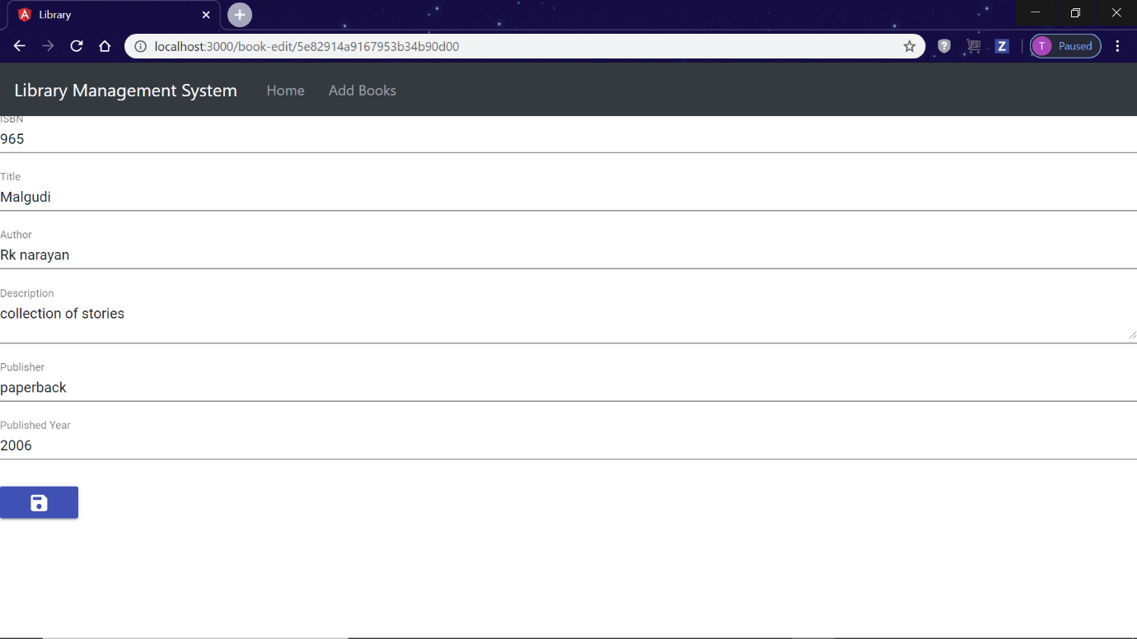

MongoDB BookDetails DB with both the documents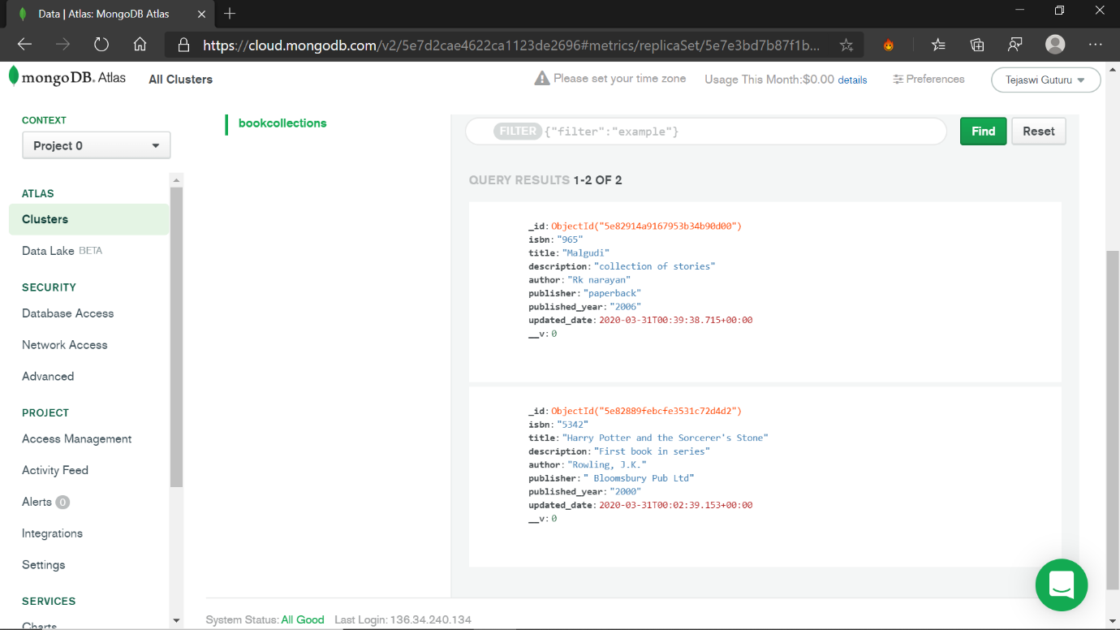

**Conclusion:**

* We analysed the given source code for this assignment. Created MongoDB account and performed CURD operations on book data. We got an idea on how a MEAN stack application works.

**Team:** Tejaswi Guturu (16); Karishma Yallanki (29)